CSC500 Module 5: Critical Thinking Assignment

Part 1 – Calculate the Average Rainfall over a period of years with Input Validation
Pseudocode
START
Set total_inches_of_rainfall = 0.0
Set total_months_count = 0
Input number of years
Validate that the number of years is a positive integer
For each year
Display the year number
For each month from 1 to 12
Input rainfall in inches for month
Validate rainfall in inches is a positive number
Add rainfall in inches to total_inches_of_rainfall
Increment total_months_count
End For
End For
Calculate average_rainfall_in_inches = total_inches_of_rainfall / total_months_count
Display total_months_count
Display total_inches_of_rainfall
Display average_rainfall_in_inches
END

Source Code
""""
Assignment 5 - - Part 1
Average Rainfall Calculation
Author: Shadab
"""
# Python code to calculate the average rainfall over the period of years using nested loops
# user provides Inputs at Runtime and also validations for inputs
total_inches_of_rainfall = 0.0
total_months_count = 0
# Validation for Number of Years Input
while True:
try:
total_years = int(input("Enter the total number of years over which average rainfall to be calculated: "))
if total_years <= 0:
print("Warning!! Please enter a valid positive integer for total number of years.\n")
else:
break
except ValueError:
print("Error!! Please enter a valid positive integer for total number of years.\n")
# outer loop will iterate once for each year
for year in range(1, total_years + 1):
print(f"\nYear {year}")
# Inner loop will iterate twelve times, once for each month
for month in range(1, 13):
#Validate Inches of Rainfall Input
while True:
try:
rainfall_in_inches = float(input(f"Enter the rainfall in inches for month {month}: "))
if rainfall_in_inches < 0:
print("Warning!! Please enter a valid positive value for rainfall in inches.\n")
else:
break
except ValueError:
print("Error!! Please enter a valid positive value for rainfall in inches.\n")
total_inches_of_rainfall += rainfall_in_inches
total_months_count += 1
average_rainfall_in_inches = total_inches_of_rainfall / total_months_count
print('\n******************** Results ********************\n')
print("Total Months :", total_months_count)
print("Total Rainfall (in Inches) :", format(total_inches_of_rainfall, ".2f"))
print("Average Rainfall per Month (in Inches) :", format(average_rainfall_in_inches, ".2f"))
print('\n**************************************************\n')

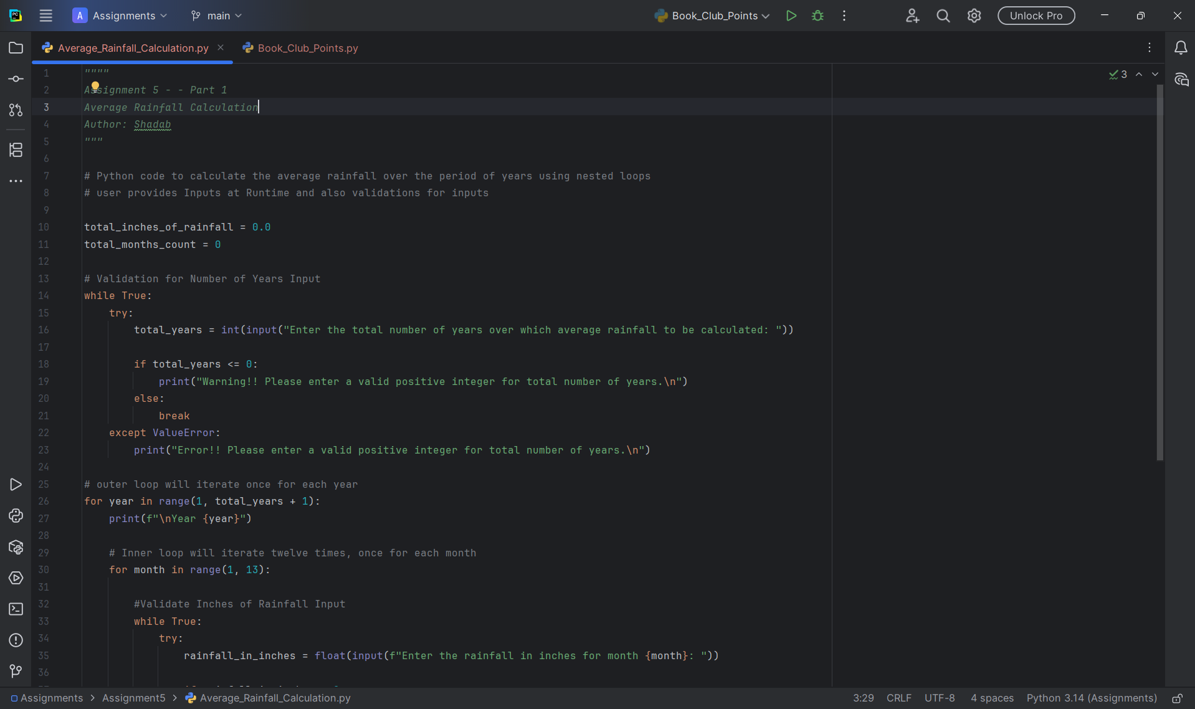

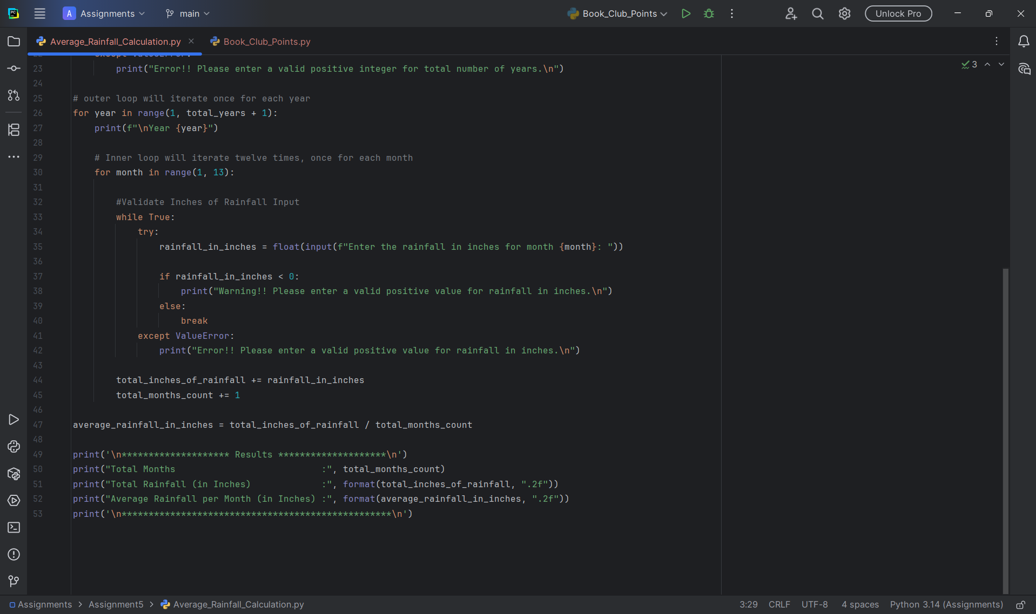

Program Execution Screenshots
Validation 1: When input is empty for Total Years
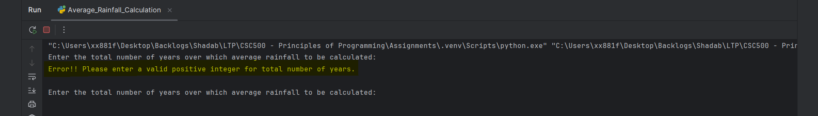

Validation 2: When input provided for Total Years is strings or special characters
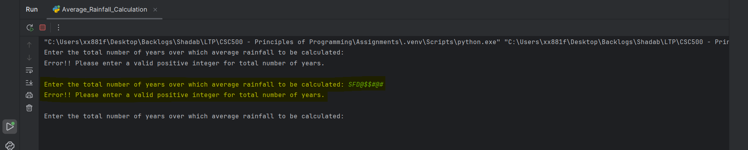

Validation 3: When Total Years provided is less than Zero
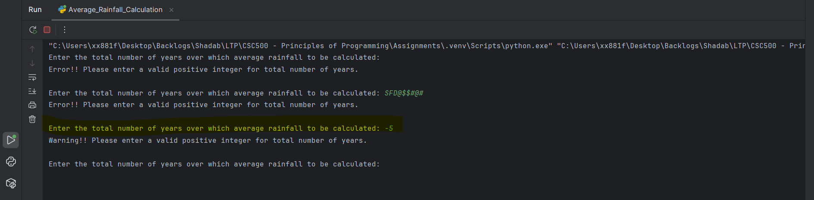

Validation 4: When Total Years provided has decimals
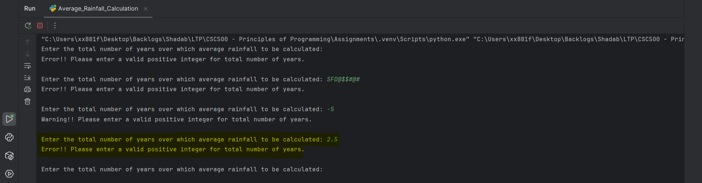

Validation 5: Valid Value for Total Years
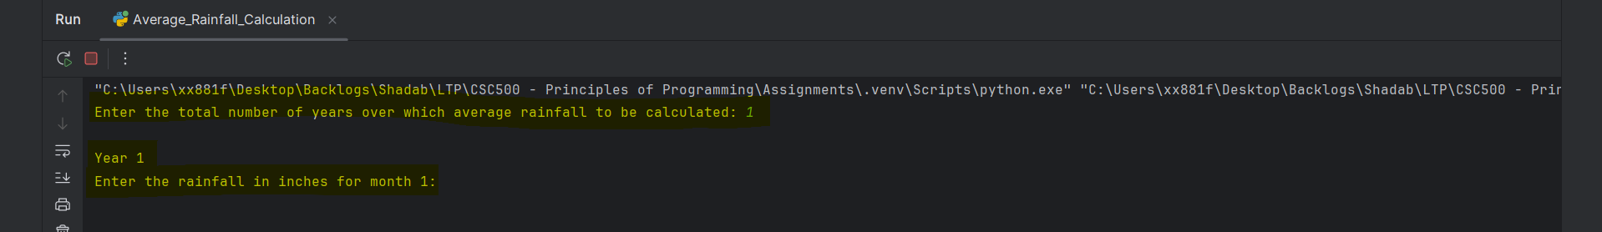

Validation 6: When Inches of Rainfall for the month provided is less than Zero
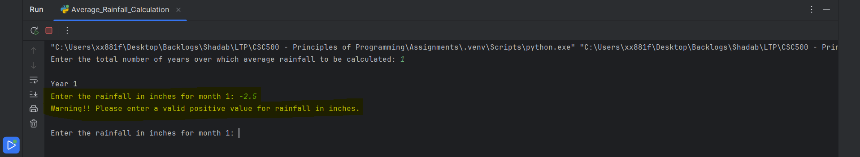

Validation 7: Valid Value for Inches of Rainfall for the month
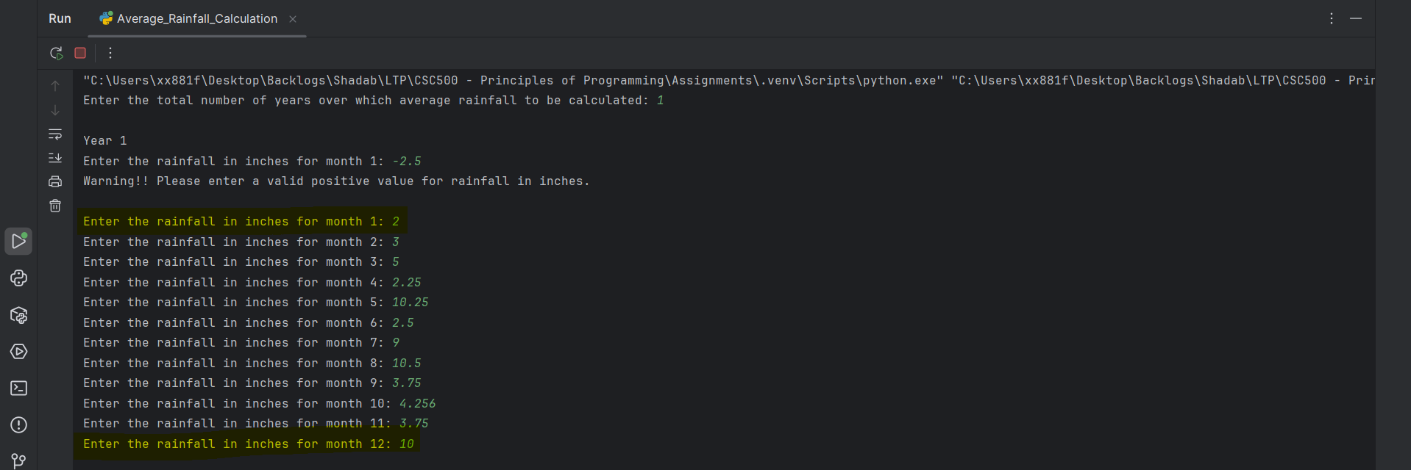

Validation 8: Average Rainfall Calculation
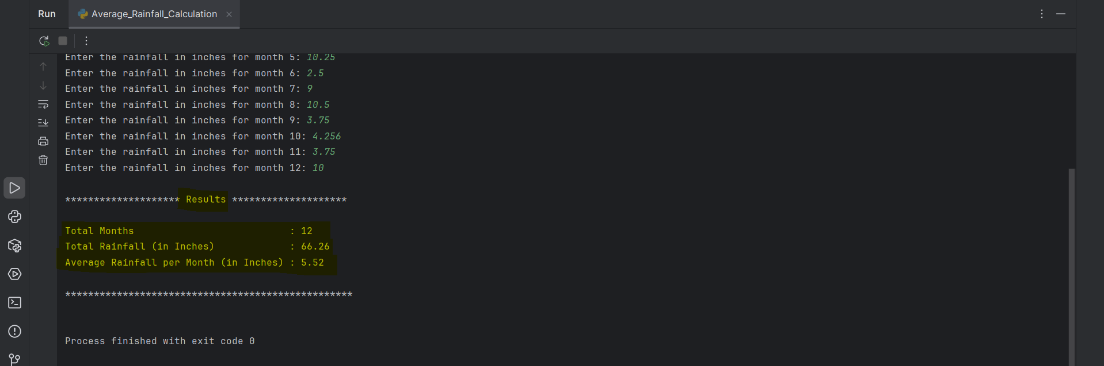

Part 2 – Calculate Book Club Points based on the Number of Books Purchased each month with Input Validation
Pseudocode
START
Input number of books purchased in a month
Validate input is an integer and not negative
If books_purchased = 0
points = 0
Else if books_purchased = 2
points = 5
Else if books_purchased = 4
points = 15
Else if books_purchased = 6
points = 30
Else if books_purchased >= 8
points = 60
Else
points = N/A
Display warning message
Display number of books purchased
Display book points awarded
END

Source Code
""""
Assignment 5 - - Part 2
Book Club Points Calculation
Author: Shadab
"""
# Python code to calculate the book club points based on number of books purchased in a month
# user provides Inputs at Runtime and also validations for inputs
while True:
try:
books_purchased = int(input("Enter the number of books purchased in this month: "))
# Validation to check inputs for books purchased is not negative
if books_purchased < 0:
print("Warning!! Number of books purchased in this month cannot be negative.\n")
else:
break
except ValueError:
print("Error!! Please enter a valid integer value for number of books purchased.\n")
# Points based on Number of Books Purchased
if books_purchased == 0:
book_points = 0
elif books_purchased == 2:
book_points = 5
elif books_purchased == 4:
book_points = 15
elif books_purchased == 6:
book_points = 30
elif books_purchased >= 8:
book_points = 60
else:
book_points = "NA"
print("\nWarning!! Points are awarded only for purchasing of 2, 4, 6, or 8+ books.")
print('\n**************** Book Club Points ****************\n')
print("Books Purchased (in Month) :", books_purchased, "Books")
if book_points == "NA":
print("Book Points Awarded :", book_points, "(Invalid number of books for points calculation)")
else:
print("Book Points Awarded :", book_points, "Points")
print('\n**************************************************\n')

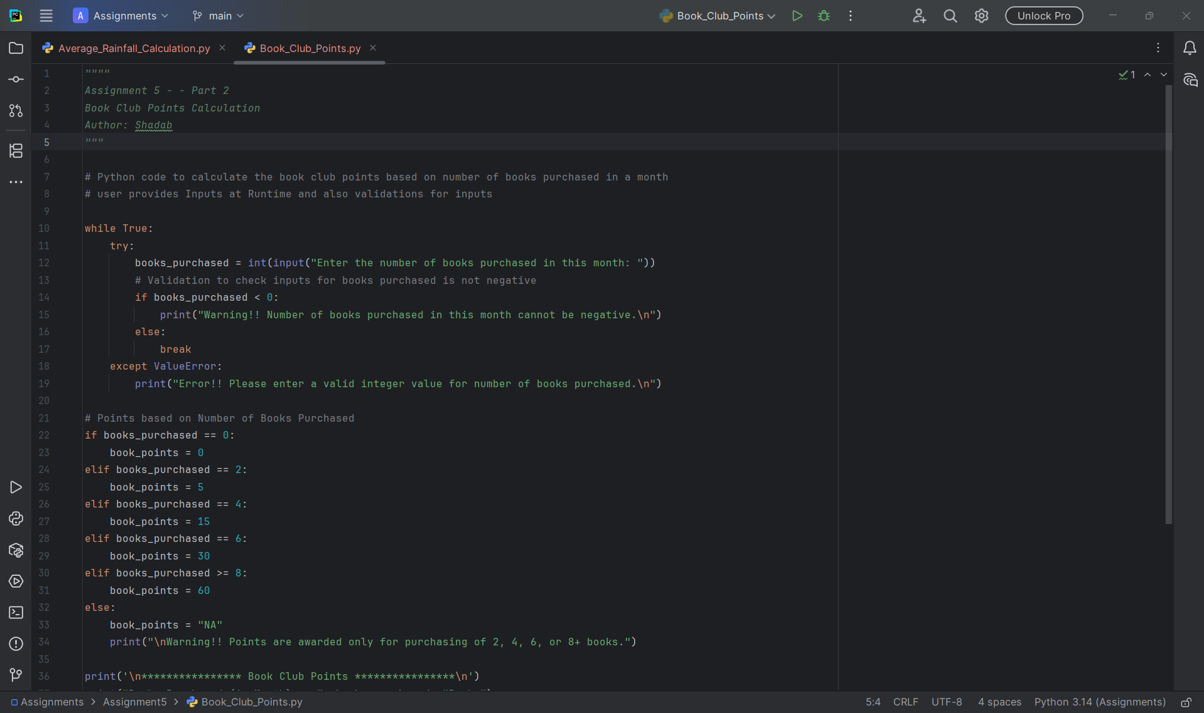

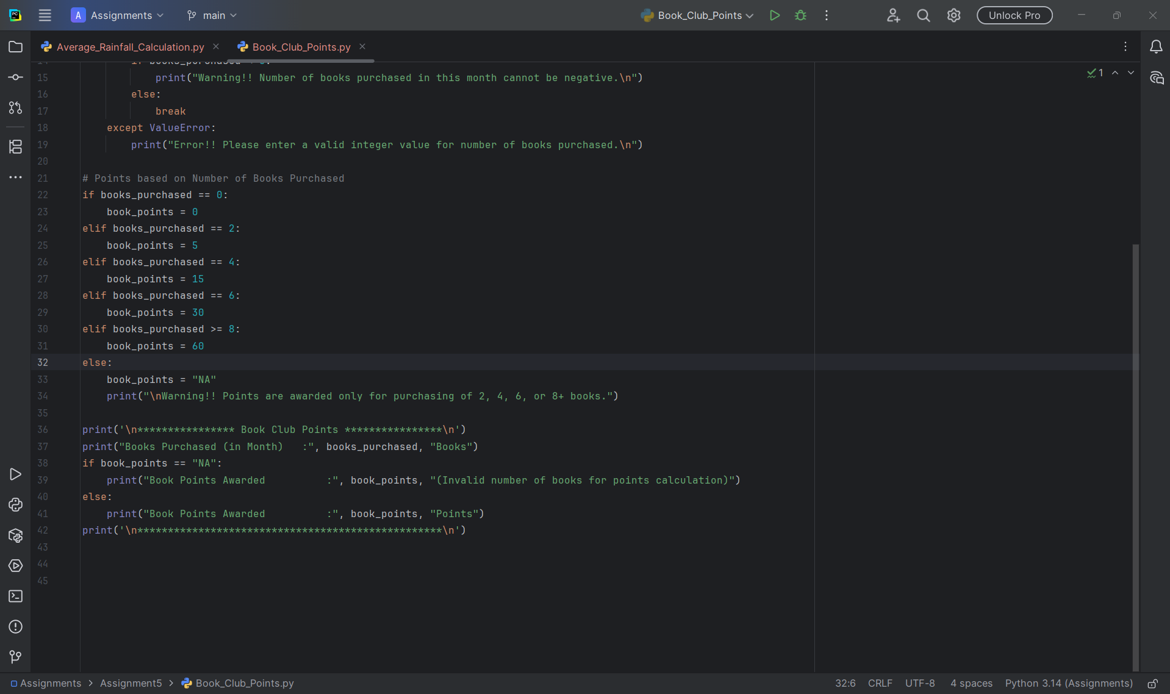

Program Execution Screenshots
Validation 1: When number of books purchased input is empty
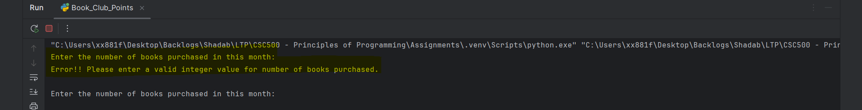

Validation 2: When number of books purchased input is strings or special characters
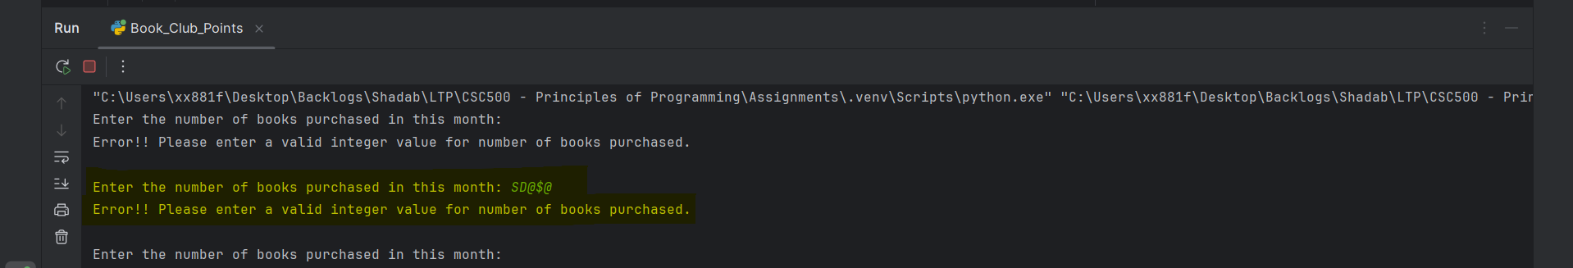

Validation 3: When number of books purchased input value is less than zero
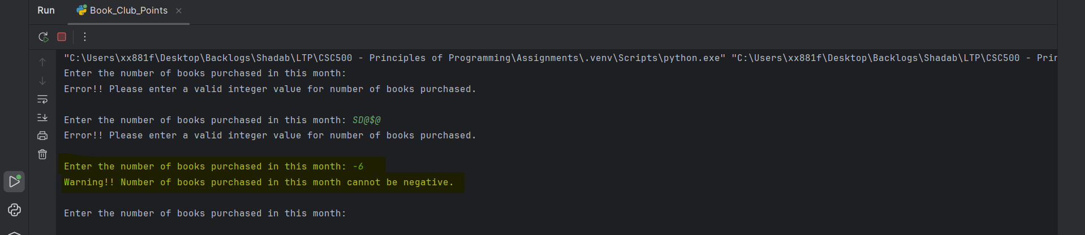

Validation 4: When number of books purchased input value is not one of 2, 4, 6, 8+
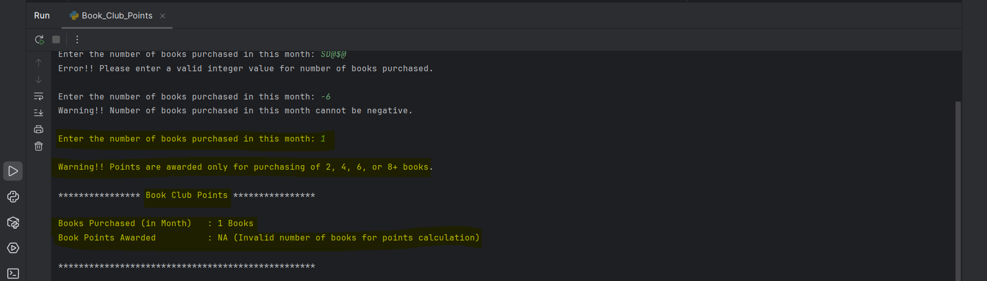

Validation 5: When number of books purchased input value is one of 2, 4, 6, 8+
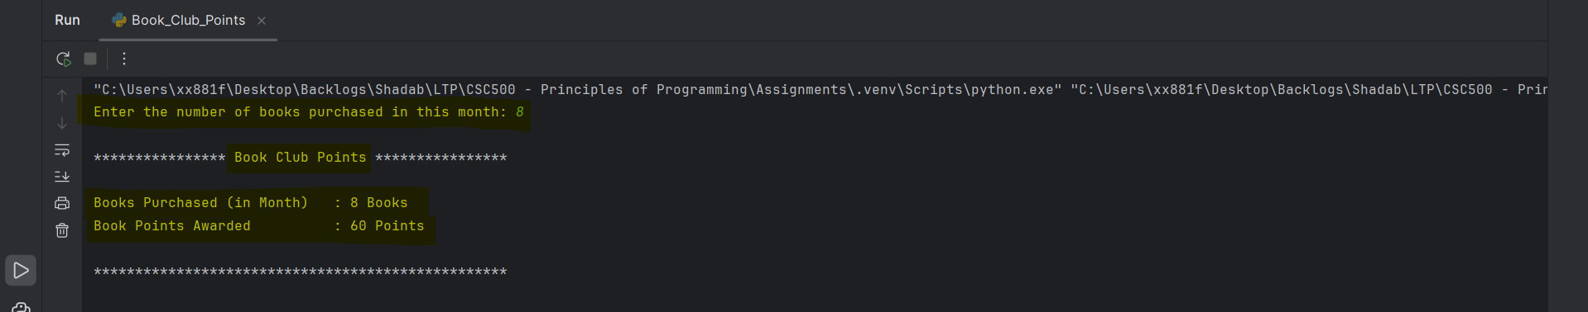

Part 3 – Git Repository
Created a Git-Hub Account with Repository name as “CSC500---Principles-of-Programming”
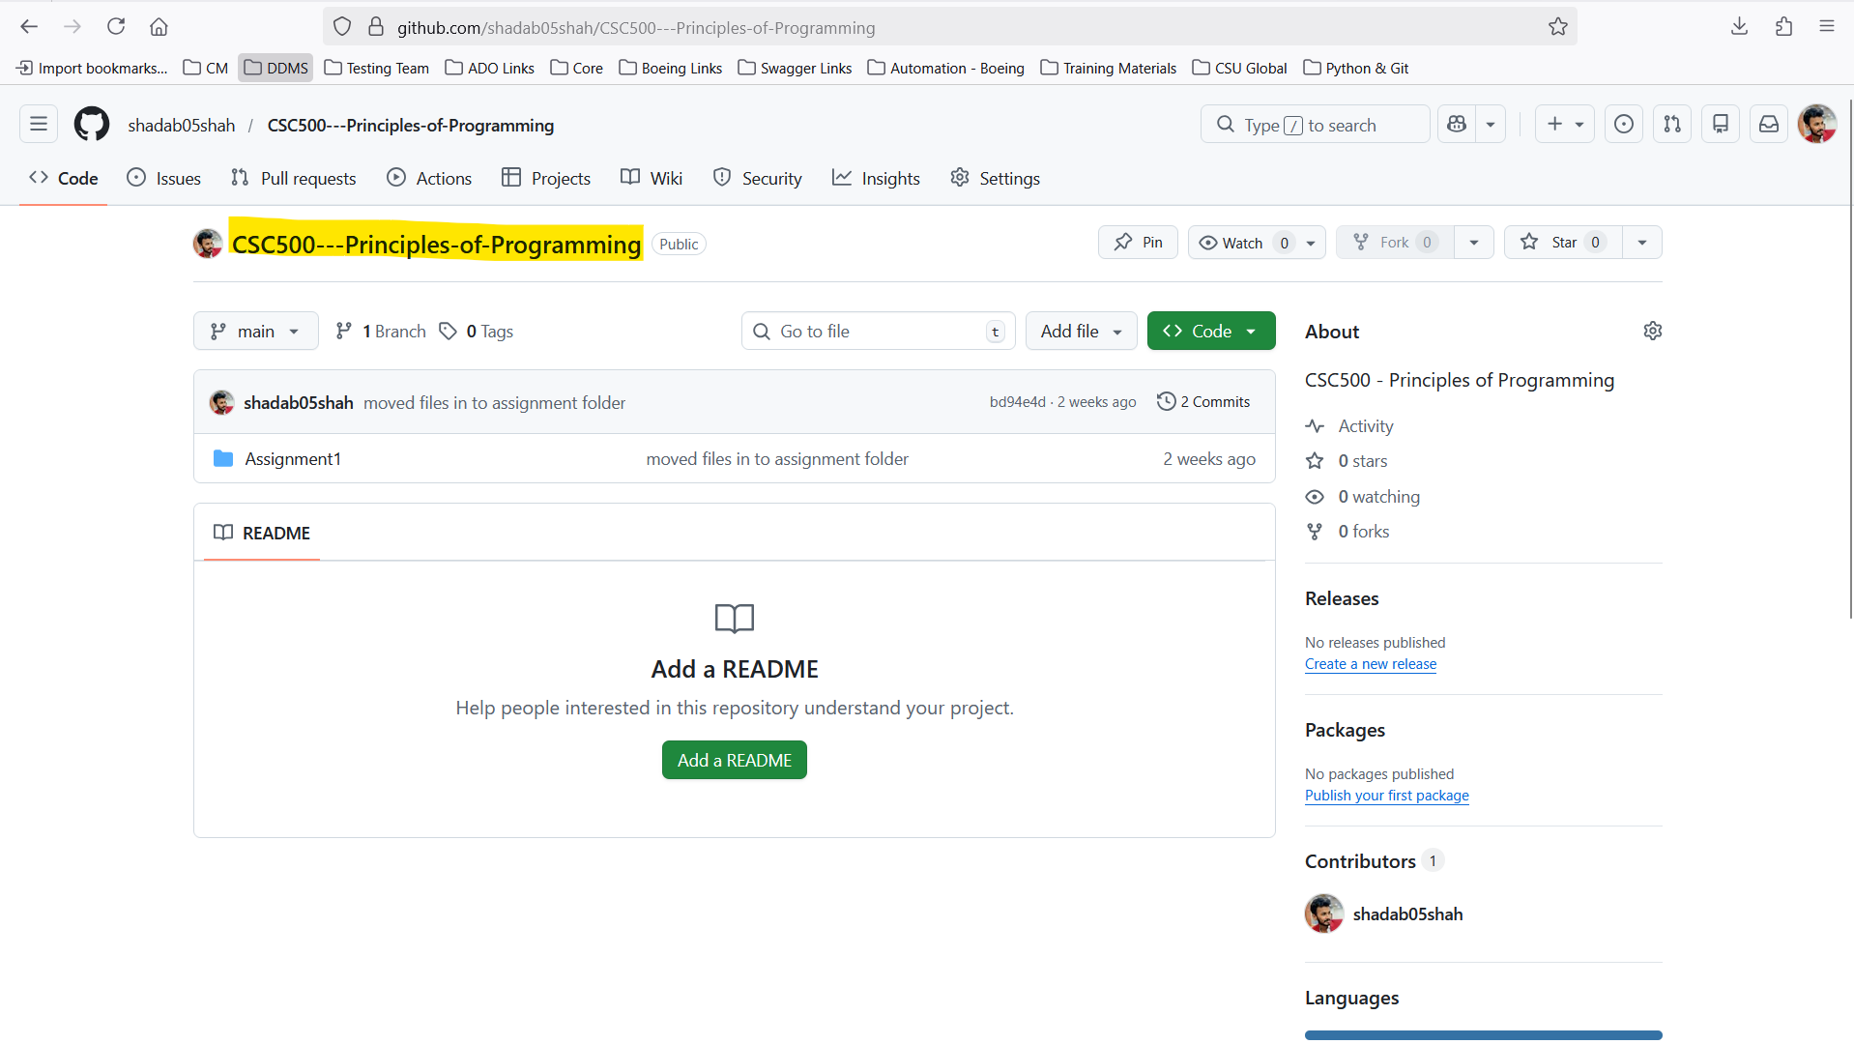

Main Project Folder Structure in Local
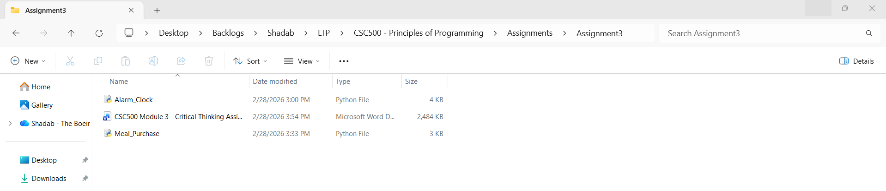

Initialize Git using “git status”
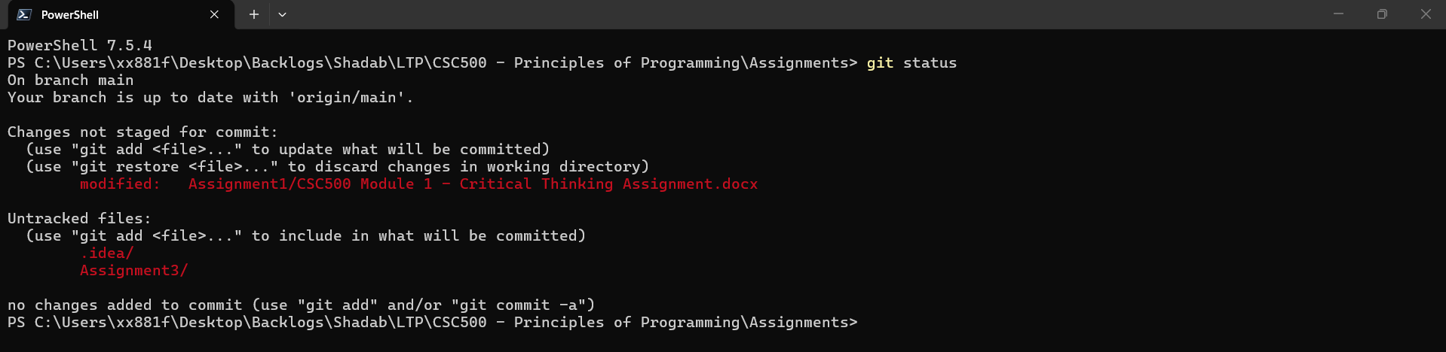

Ignore .idea folder
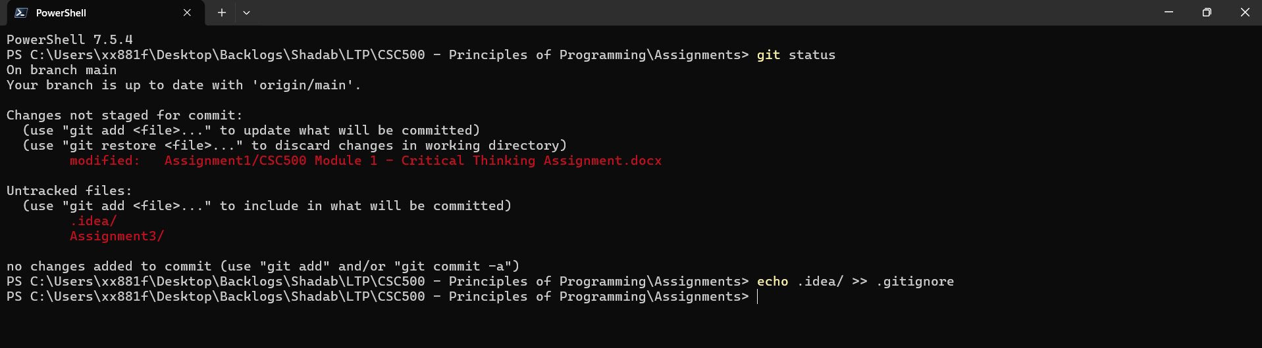

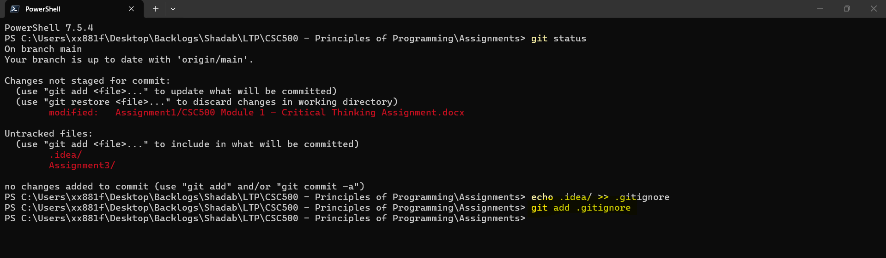

Adding only Assignment3 folder
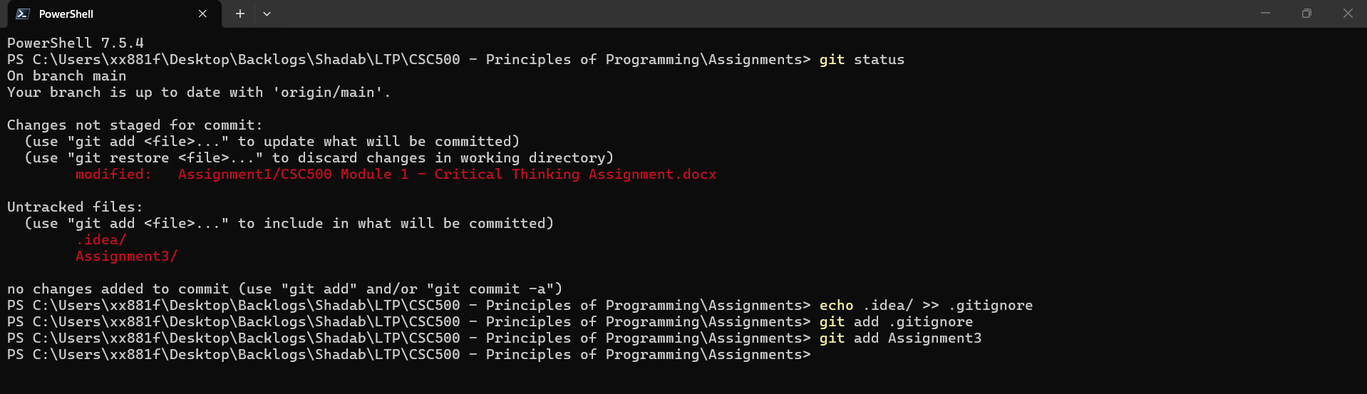

Commit Changes
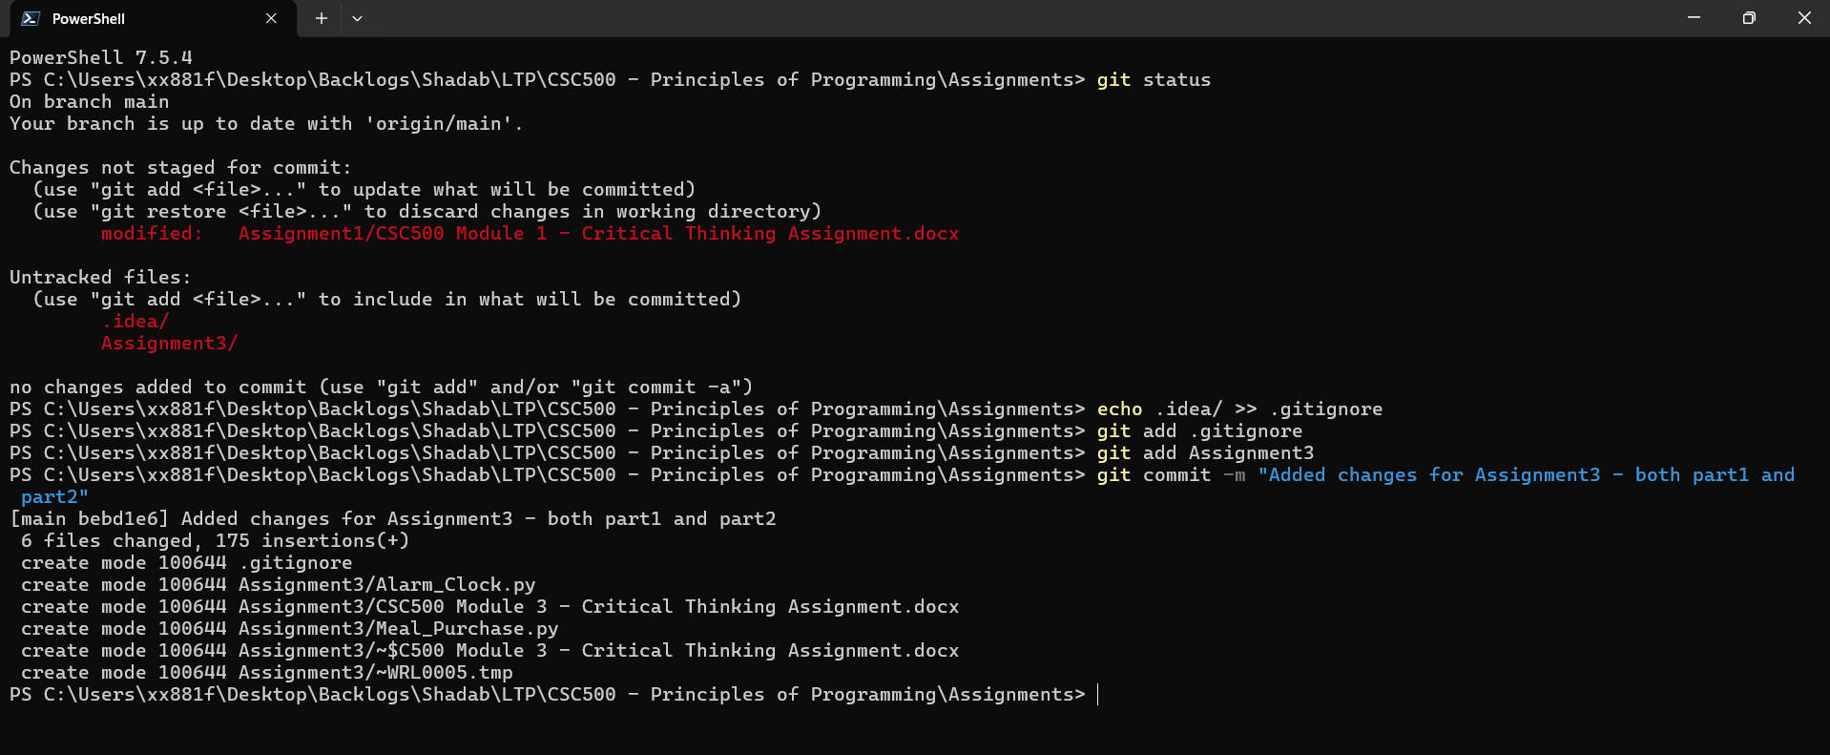

Pushing the Changes
git push origin main
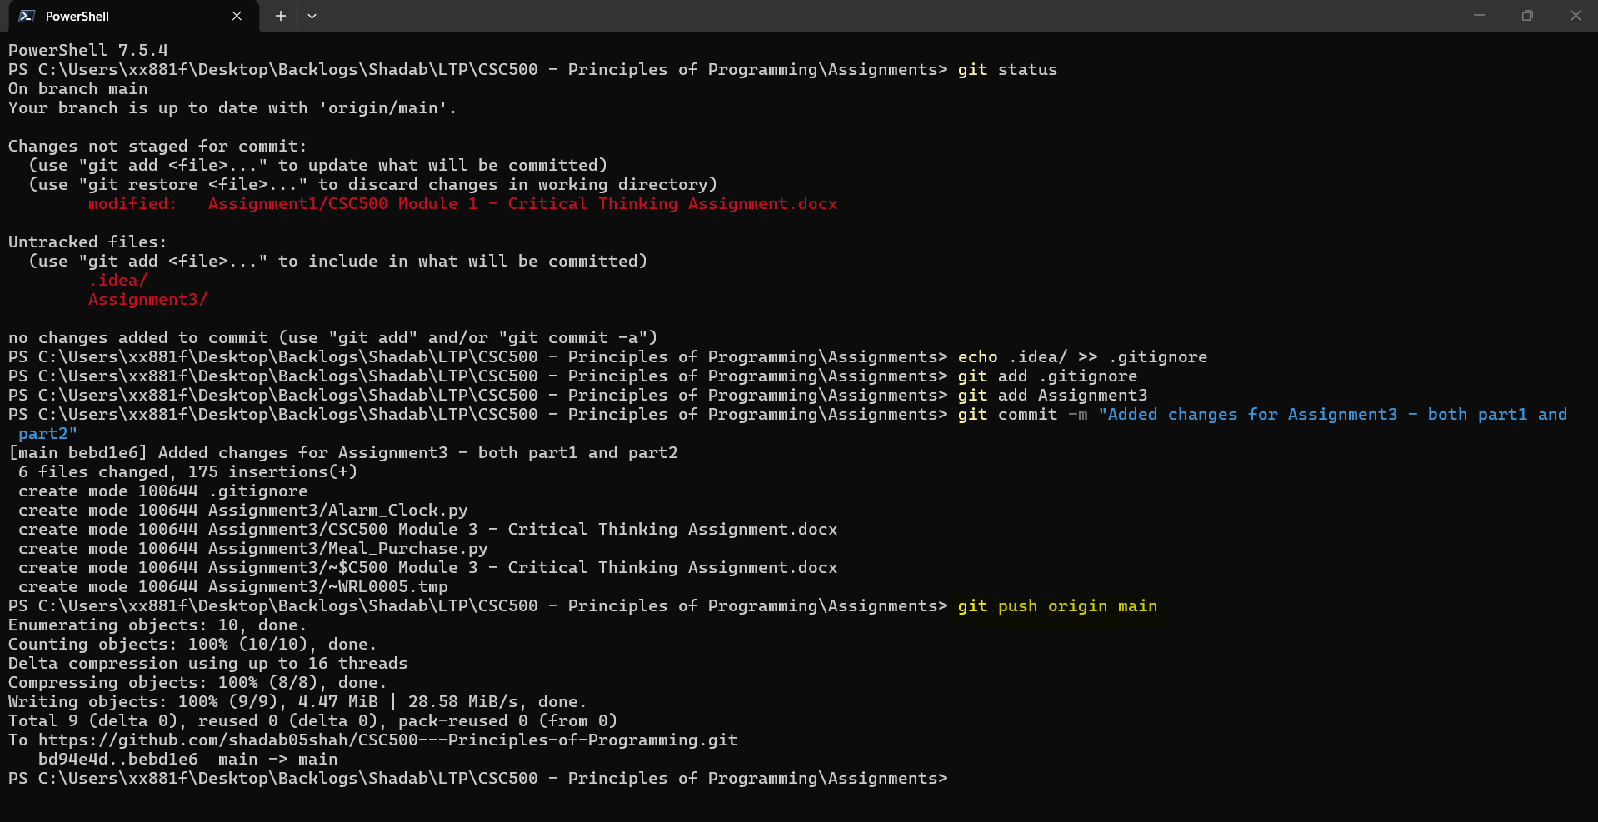

Checking Status
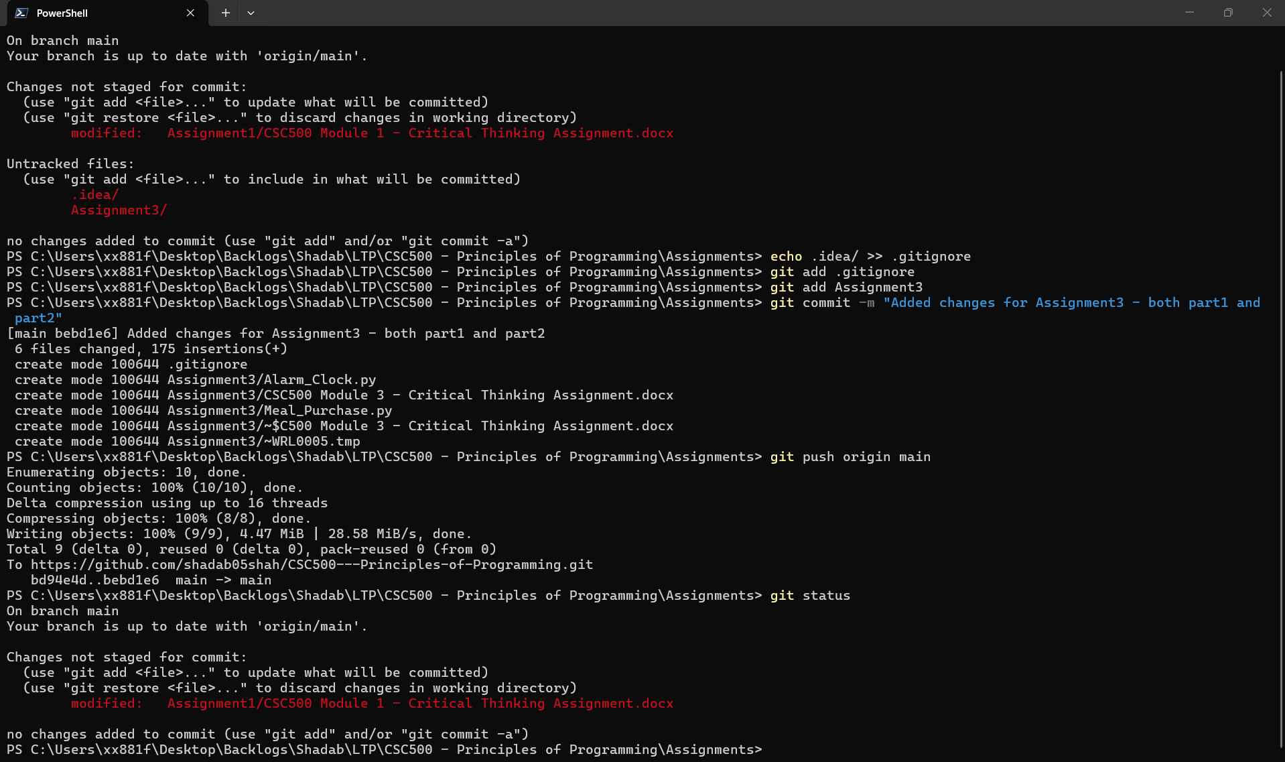

In Git-Hub repo page
